Exp: Experiment 3
Aaron Gomes
UID: 2025300073

Aim:
- Find the length of the length of the string “Hello World”
- Compare two strings “HELLO”

CODE:
.MODEL SMALL
.STACK 100H

.DATA
STR1 DB "Hello World$" ; The target string terminated with '$'
LEN DB 0 ; Memory variable to store the final length

.CODE
MAIN PROC
; Initialize the Data Segment
MOV AX, @DATA
MOV DS, AX

; Load the address of the string and clear the counter
LEA SI, STR1 ; SI points to the start of the string
XOR CX, CX ; Clear CX register (Counter = 0)

COUNT_LOOP:
MOV AL, [SI] ; Move the current character into AL
CMP AL, '$' ; Check if it is the terminator character
JE DONE_LOOP ; If '$' is found, jump out of the loop

INC CX ; Increment the character count
INC SI ; Move to the next memory address
JMP COUNT_LOOP ; Repeat for the next character

DONE_LOOP:
MOV LEN, CL ; Save the lower byte of the count into LEN

; Proper termination to hand control back to DOS
MOV AH, 4CH
INT 21H
MAIN ENDP
END MAIN

OUTPUT 1:
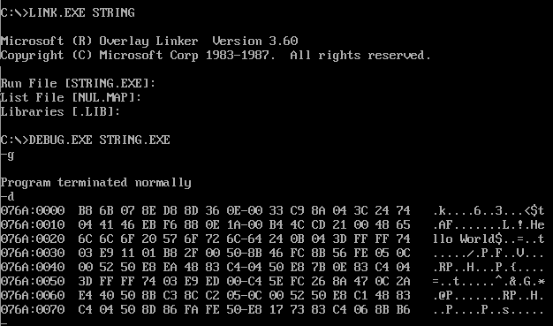

Code 2:
.MODEL SMALL
.STACK 100H

.DATA
STRING1 DB 'HELLO$'
LEN1 EQU $ - STRING1 - 1 ; Moved here! Now LEN1 correctly equals 5
STRING2 DB 'HELLO$'

MSG_EQUAL DB 'Strings are equal.$'
MSG_NOTEQUAL DB 'Strings are NOT equal.$'

.CODE
MAIN PROC
MOV AX, @DATA
MOV DS, AX ; Load Data Segment
MOV ES, AX ; Load Extra Segment

LEA SI, STRING1 ; SI points to source string
LEA DI, STRING2 ; DI points to destination string
MOV CX, LEN1 ; CX is now correctly set to 5

CLD ; Clear direction flag

REPE CMPSB ; Compares 5 bytes ('H','E','L','L','O')
JNE NOT_EQUAL ; Jumps only if bytes differ

EQUAL:
LEA DX, MSG_EQUAL
JMP DISPLAY

NOT_EQUAL:
LEA DX, MSG_NOTEQUAL

DISPLAY:
MOV AH, 09H
INT 21H

MOV AH, 4CH
INT 21H
MAIN ENDP
END MAIN

OUTPUT 2:
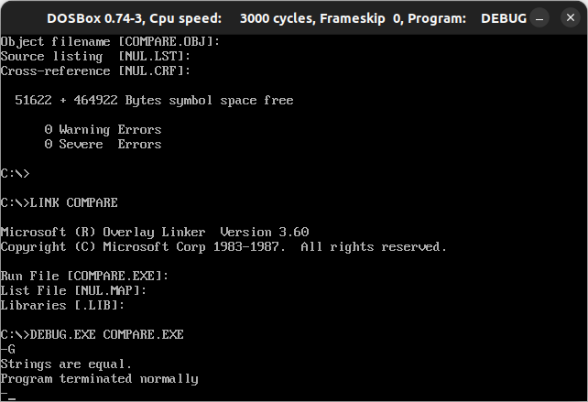

Conclusion:
Assembly code executed and output was viewed via the debug commands.

